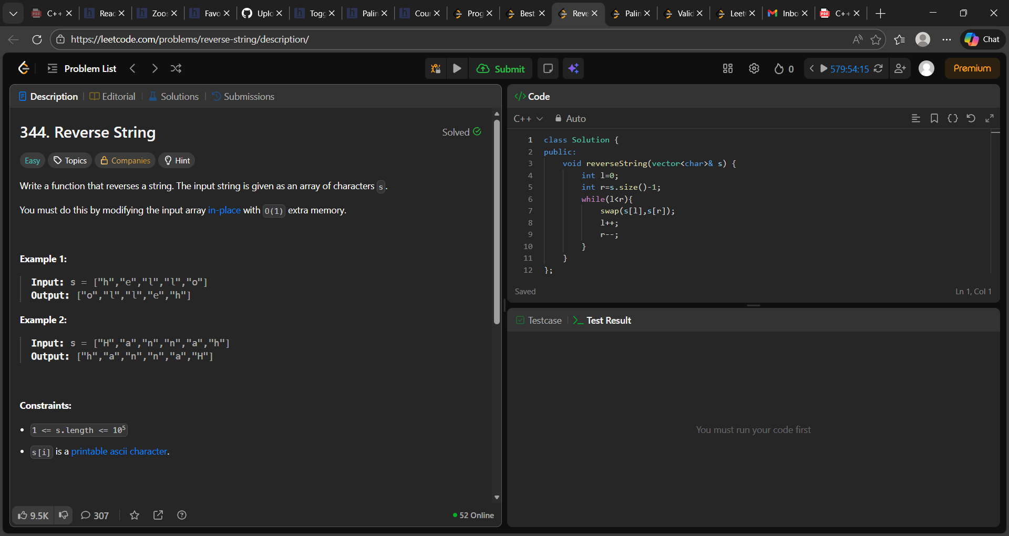

class Solution {
public:
void reverseString(vector<char>& s) {
int l=0;
int r=s.size()-1;
while(l<r){
swap(s[l],s[r]);
l++;
r--;
}
}
};

